**Testing 360 Home Décor( Book Appointment)(** [**https://360homedecor.uk/book-appointment**](https://360homedecor.uk/book-appointment)**)**

**( Book Appointment)**

**1)**In the First name it is accepting the Integers and Symbols and taking only about 30 words first name

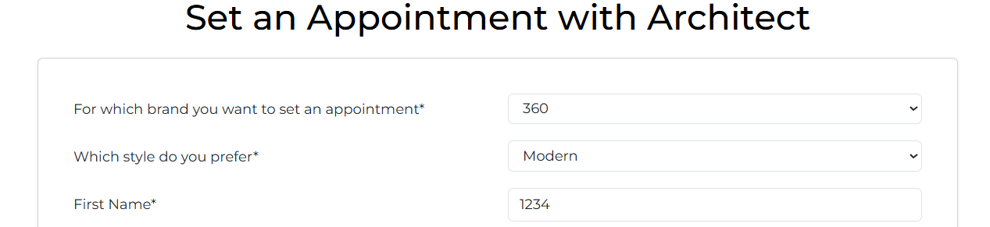

**2)**In the Last Name accepting the Integer and Symbols values and not taking more than 30 words last names

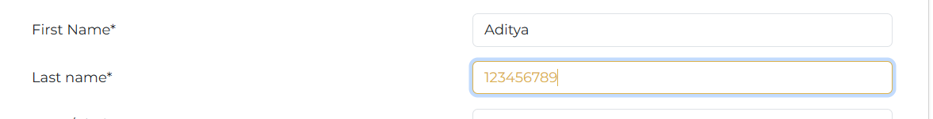

**3)**Town/City is also accepting integer values and not letting more than 30 words

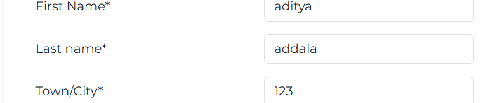

**4)**In phone number it is Resistering successful even without 10 digit phone number





**5)**Email is mandatory (*)But form is submitting even mail is not provided

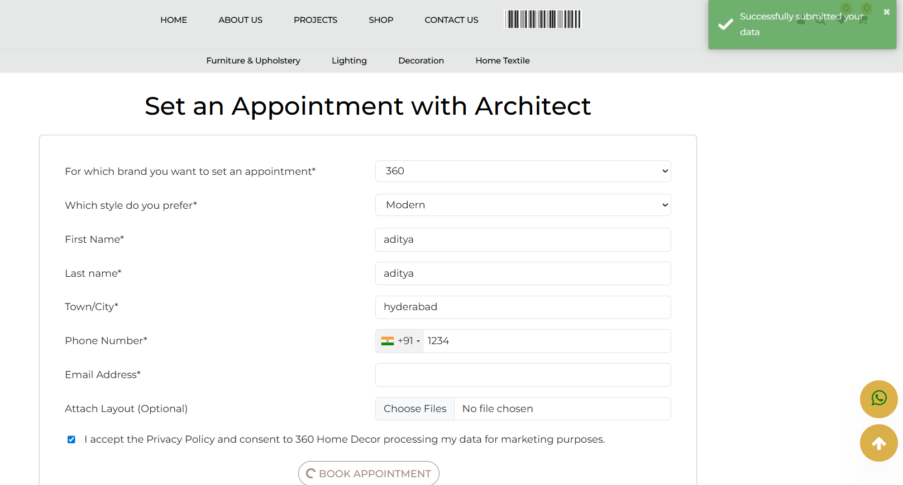

Form is accepting without @ in Mail

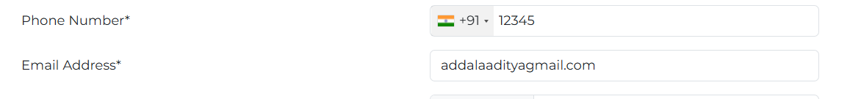

**6)**Accepting even if “Privacy Policy” Checkbox is not Ticked

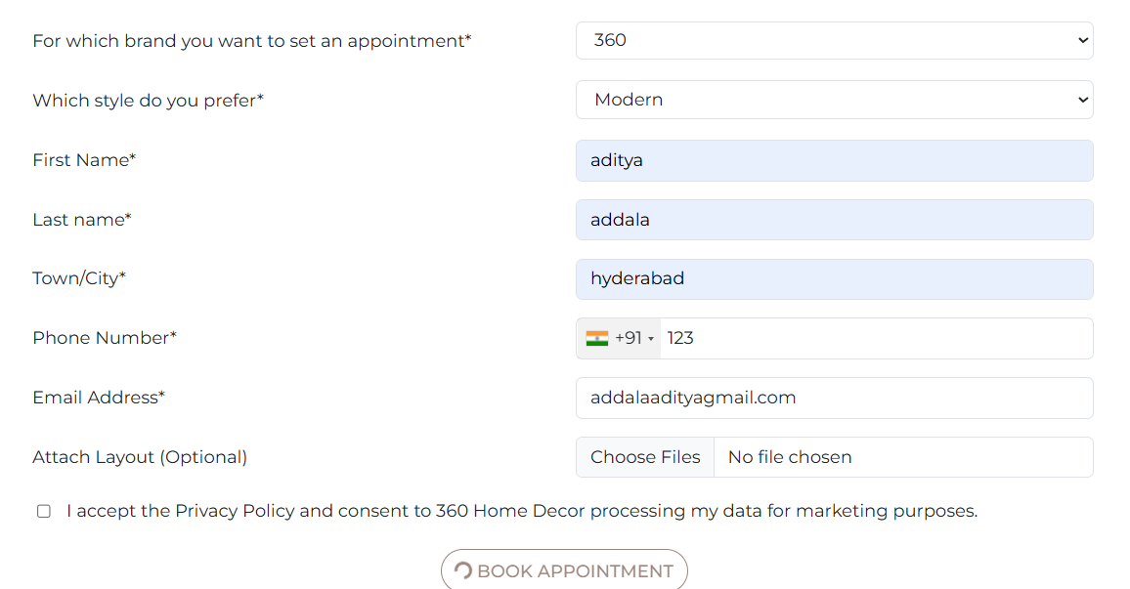

**By using Test Case Data**

